
UkweliSRHR — what’s new in this build
Changes made after the youth test run · 2–5 October 2026
ImaarishaSRHR · Community Media Trust

At a glance
Young people tested UkweliSRHR and told us what got in their way: they couldn’t find their answers again, weren’t sure what “anonymous” meant, saw what looked like someone else’s story, and found the app slow to respond and generic in tone. This build responds to every one of their 16 points and adds two things they asked for indirectly — a clear way to keep up with new laws and health options, and a cleaner Trending feed.
16  feedback points acted on | 11  “Catch the Latest” updates, English + Kiswahili | 120 → 14  Trending entries reviewed; genuine claims kept | 9  facilities young people named, added to verify

The three most important changes: young people can now get their answers back with a private code; they choose whether an answer is shared or private; and the app never silently fails or loses their work.

What young people said — and what changed
# | What young people said | What we changed | Status
1 | Saw another person’s story after asking | Public answers now clearly labelled “Questions other young people asked”, each marked “Asked anonymously”. Askers choose: share anonymously, or keep the answer just for them. | Done
2 | Couldn’t get their answers back | Every question gets a private code (only a scrambled version is stored) and a “My questions” page to read answers. | Done
3 | Unsure what “anonymous” means | Three-step “How it works” box before asking; plain privacy line under the button. | Done
4 | Accounts — optional, not forced | No accounts needed. Codes give the benefits of an account without collecting anything identifying. | Done
5 | Too many clicks / seemed not to respond | The question box is the first thing on the screen; the button always responds; the security check runs invisibly. | Done
6 | Questions didn’t submit | Failures were silent before. Every send now ends in a clear success or error message, and the question is kept if it fails. | Done
7 | Answers felt generic / “AI” | AI drafting rewritten to answer the exact question first, in plain, warm language. New admin list to review and fix published answers. | Done — keep reviewing
8 | English & Kiswahili core; Sheng needs work | EN/SW are the core; Sheng is an optional layer. Leftover English-only text translated. AI Sheng drafts now written in real Sheng. | Done — needs youth review
9 | Hard to type everything | “Speak instead” button on supported phones, plus a keyboard-microphone tip. | Done
10 | Add Mental Health & SRHR | New Learn topic in English and Kiswahili, with Kenyan helplines. | Done
11 | More youth-friendly facilities | Admin facility editor; 9 places young people named added as hidden drafts to verify. | Started — phone to verify
12 | Show the cost of services | Cost (free / low cost / paid / varies), hours, phone, ages and “details checked” date on every facility. | Done — fill in details
13 | Juja Road, Mathare, Dandora, MSF | Researched: Dandora Youth Friendly Centre, MSF Lavender House (Juja Road), Mathare North and others added as drafts. | Started — phone to verify
14 | Questions with photos | Optional photo, cleaned of hidden data on the phone, private to the health team, deleted once answered. | Done
15 | Looks generic / “AI-generated” | Line icons instead of emoji, one calm accent colour, no glowing gradients, plainer wording. | Done
16 | Keep Myths, Trending, Learn | Kept and strengthened: “Catch the Latest” added; Trending cleaned and reviewed. | Done

1. Privacy and getting answers back
The most urgent concern was a young person seeing what looked like another person’s story after asking. The likely cause: the Ask screen showed other people’s answered questions straight under the form, with no label. We could not confirm this against live data, so the fix covers both clarity and control.
- Clear labelling. The public list is now headed “Questions other young people asked — shared anonymously with permission”, and each card says “Asked anonymously”.
- Askers choose. Before sending, they pick “Share it anonymously so others can learn too” or “Keep the answer just for me”. Private answers never appear in the public list.
- A private code for every question. After sending, the young person gets a code like 6A36-F5GA-TQ9G. Only a scrambled version is stored, so no one — not even admins — can link a question to a person. The code opens their answer on the new “My questions” page, on any phone.
- Shared phones. Codes are remembered on the phone only if the young person leaves that box ticked, and “Forget my questions on this phone” clears them. The Exit button also wipes any half-written question.

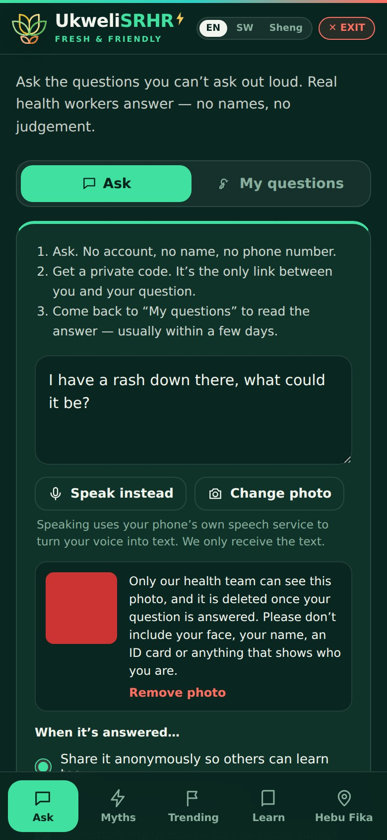  Asking: how it works, share or keep private | 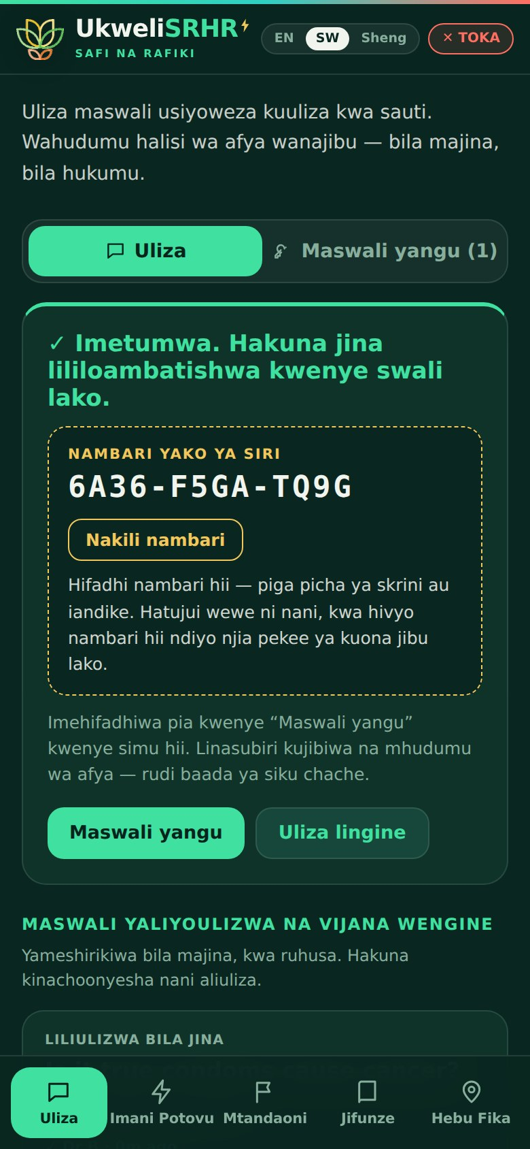  After sending: the private code (Kiswahili) | 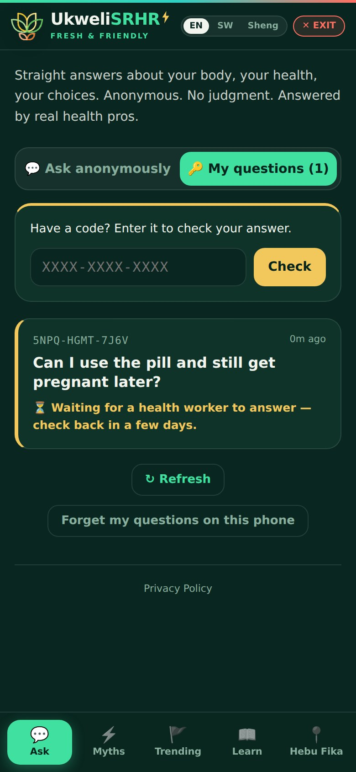  “My questions”: check an answer with a code

2. Asking is quicker and clearer
- Always responds. The button reacts every time. If the security check isn’t finished, the app says so and sends as soon as it is — no more “is my internet slow?”.
- Clear outcomes. Previously, a failed send reset silently. Now every send ends with the code or a plain error, and the question stays in the box.
- Speak instead. On phones that support it, young people can talk instead of typing. The app says plainly that the phone’s own speech service turns voice into text and we only receive the text.
- Photo questions. Optional. The phone removes hidden data (location, phone model, time) before sending; only the health team can see the photo; it is deleted automatically once the question is answered or closed. The screen asks young people not to show faces, names or ID.

3. Keeping your place
Leaving the app — to answer a message, or by losing signal — no longer throws work away.
- In UkweliSRHR: the tab and the item a young person had open (a myth, a Learn topic, a county, an update) are part of the page link, so coming back returns them to the same spot. A half-written question survives leaving and returning, but is cleared when the tab is closed or Exit is pressed, so it never sits on a shared phone.
- In Admin: the desk you were on, any editor you had open and every half-written answer are saved on that computer until you publish or sign out. The question you were working on is scrolled back into view and highlighted. A loading hiccup can no longer wipe drafts, and pressing “AI draft” keeps your own wording (“Restore my own draft”).

4. New and improved content

Catch the Latest (Trending tab)
A new section that explains recent court rulings, laws, policies and new health options in plain language: what happened, what it means for you, where it stands now, plus free helplines on sensitive topics and links to sources. It launched with 11 updates in English and Kiswahili, including:
- High Court, May 2026: teens in consensual, close-in-age relationships shouldn’t be prosecuted — with a clear note that the age of consent is still 18.
- Court of Appeal, April 2026: the 2022 ruling calling abortion a right was overturned (now at the Supreme Court).
- The twice-yearly HIV prevention injection (lenacapavir), rolled out from February 2026; the one-dose HPV vaccine; the GBV and femicide report; the right to return to school.
Every legal update carries a “general information, not legal advice” note.

Spreading right now (Trending) — cleaned and reviewed
Young people saw lines of raw web code in this feed. The cause was the scanner decoding feed text in the wrong order. It is fixed in the scanner and in both apps. We then reviewed all 120 entries shown to young people: about 40 were repeats, many were not misinformation (regulator warnings, fact-checks), and many came from other countries or were years old but showed as “0m ago”. Young people now see 14 genuine, relevant claims with their real publication date. The hub’s Radar still keeps everything, and the team can show or hide any item.

Mental Health & SRHR (Learn)
A new topic, as the young people asked: how feelings and sexual and reproductive health affect each other, signs to take seriously, stigma, pregnancy and after birth, small things that help, and where to talk now (Kenya Red Cross 1199, Befrienders Kenya, One2One 1190).
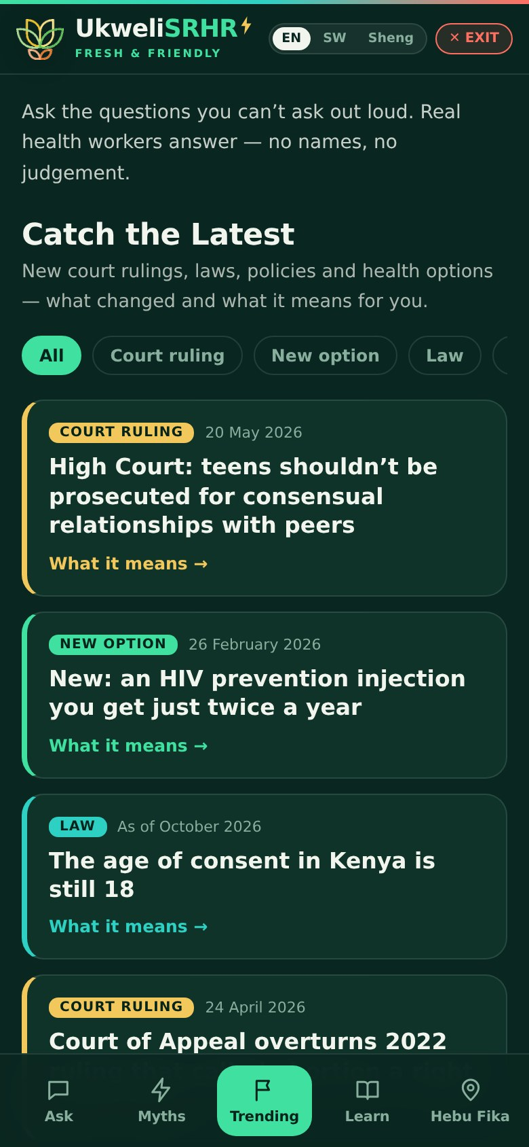  Catch the Latest | 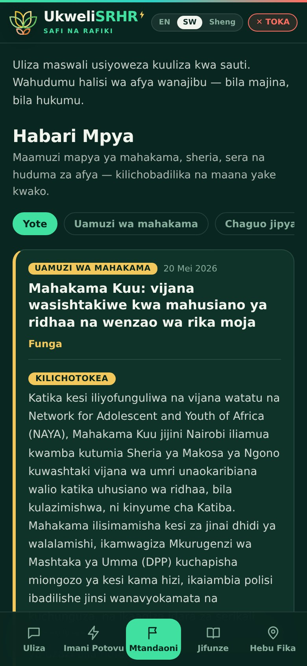  The same update in Kiswahili | 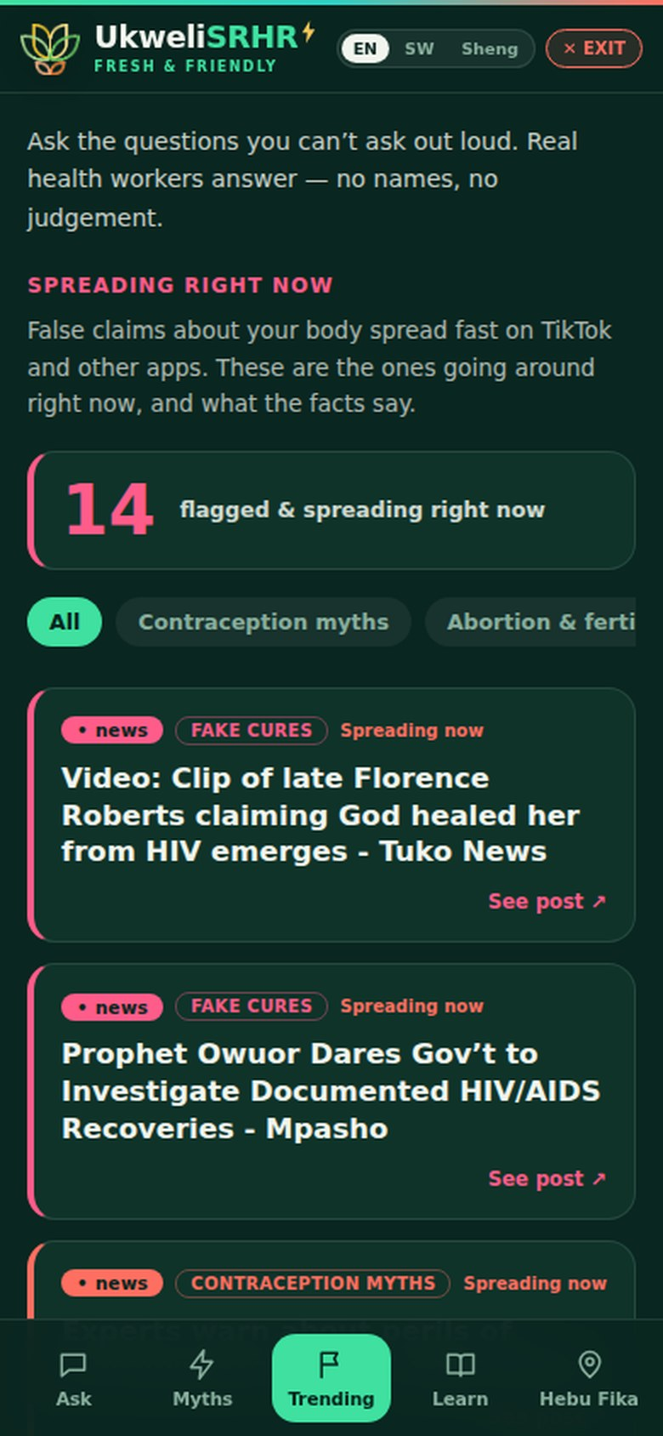  Spreading right now, after review | 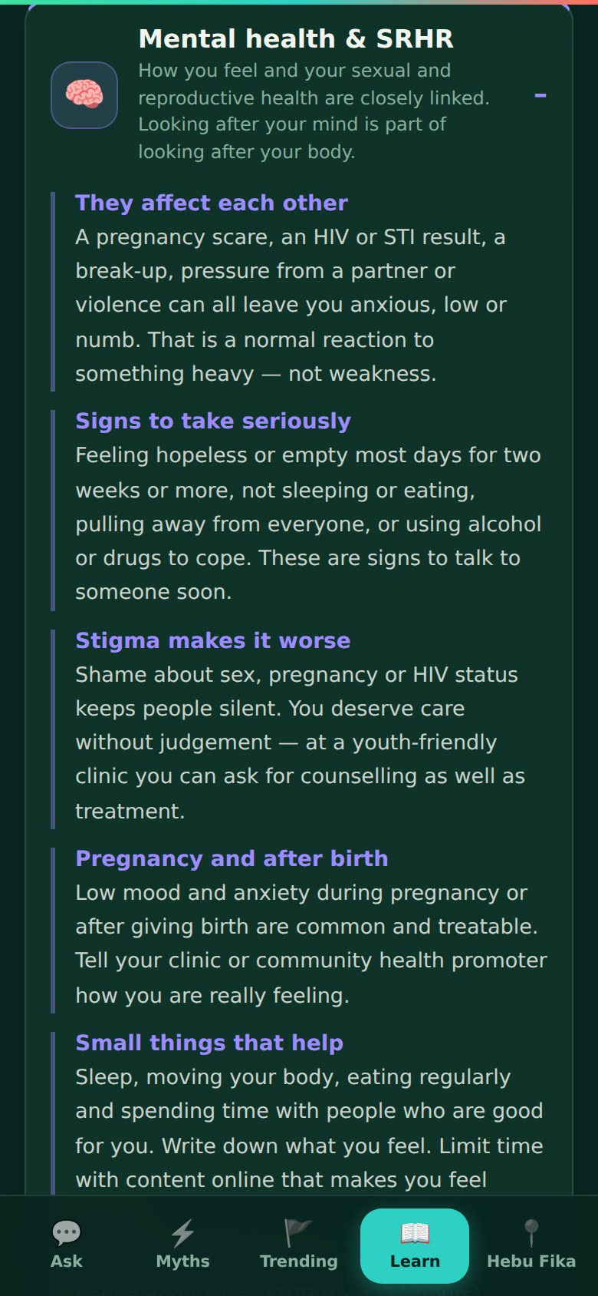  New Mental Health topic

5. Hebu Fika: facilities and costs
- Cost shown up front. Each facility shows Free, Low cost, Paid or Cost varies — or “Cost not confirmed — ask before you go” when unknown — plus opening hours, ages served, a tap-to-call number and when the details were last checked.
- Places the young people named. Researched and added as hidden drafts: Dandora Youth Friendly Centre (ages 10–24, run with MSF), Dandora II Health Centre (the “Dandora Level II” in the feedback), MSF Lavender House on Juja Road (free, 24 hours), Mathare North, Pumwani Maternity, the new Tumaini Clinic at KUTRRH and others. None goes live until someone phones them and ticks “Show in the app”.
- Facility editor. Admin → Hebu Fika → Facilities lets the team fill in and update all of these details.
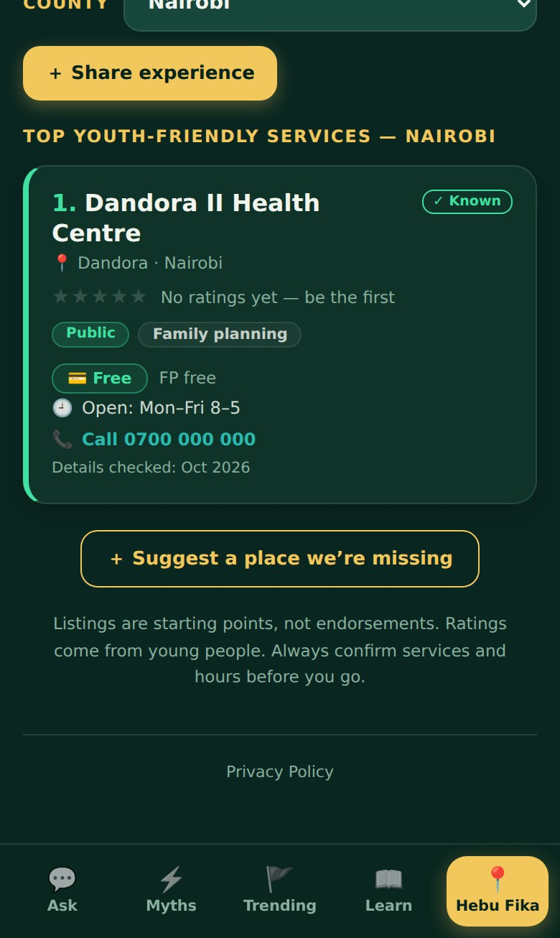
Facility card with cost, hours and contact

6. Language, look and wording
- English and Kiswahili are the core languages; Sheng is an optional informal layer. Text that used to stay in English whatever you chose is now translated, and the app says when something isn’t available in a language yet.
- Sheng drafts. When the team drafts an answer or update in Sheng, the AI now writes real Sheng rather than English with a few Sheng words. Every Sheng text should still be read by a young person before publishing.
- Less “AI-generated”. Simple line icons replace emoji, the menu uses one calm colour, glowing gradients are gone, and the wording is plainer and warmer — for example: “Ask the questions you can’t ask out loud. Real health workers answer — no names, no judgement.”

7. New tools for the team (Admin)
Tool | What it does
Email alert on every question | imaarishasrhr@gmail.com gets an email for each new question, showing the language, whether the asker wants it private, whether it has a photo, and a button straight to the Uliza desk.
AI drafting — fixed | Drafting had stopped working (an out-of-date model name, and an admin check that rejected valid sign-ins). Fixed, and any future problem now shows a clear message.
Pop-up messages | The standalone admin app never showed messages before — successes and errors were silent. They now appear.
Review published answers | Uliza desk → “Review published answers”: edit wording in place or send an answer back to the queue.
Latest desk | Add, edit, pin, hide and translate “Catch the Latest” updates. Paste an article; “Draft with AI” fills the fields from that text only, for the team to check.
Trending show / hide | See every scanned news item and decide what young people see.
Facilities editor | Set cost, hours, phone, ages and the “details checked” date; show or hide listings.
Private photos | Photos appear only to admins and are deleted automatically on answering or hiding.

8. What still needs people
Before promoting the new build
Sheng: have young native speakers read the Sheng wording in the app and any AI-drafted Sheng before it is published.
Facilities: phone each of the 9 draft listings, confirm services, cost and hours, then show them.
Catch the Latest: check whether the State has appealed the May 2026 teen-relationships ruling, and confirm lenacapavir’s cost and minimum age.
Answers: work through “Review published answers” for relevance, grammar and tone.
Photos: keep an eye on the photo storage for misuse (each file is capped at 3 MB).

9. Technical record
For the developer and anyone maintaining the platform.
Item | Detail
Database updates (run in order) | 20261002120000_ukweli_youth_feedback · 20261002130000_ukweli_photos_facilities · 20261002140000_ukweli_latest · 20261002160000_trending_review (run once)
Server functions updated | turnstile-verify (private codes, photos) · activity-notify (question emails) · uliza-draft (AI drafting, Latest, Sheng) · radar-scanner (clean text, de-duplication, youth filter)
Apps | ukweli (youth app) and hub2 (hub and admin), both deployed by Vercel from the main branch
Commits | 6d7ac75 · 450f502 · 8393aea · 97994b8 · 98444c0 · 7b07da1 · 383e723 · 0049689
Privacy by design | No accounts or names; only a hash of each private code is stored; photos private and auto-deleted; drafts cleared on Exit or sign-out.

